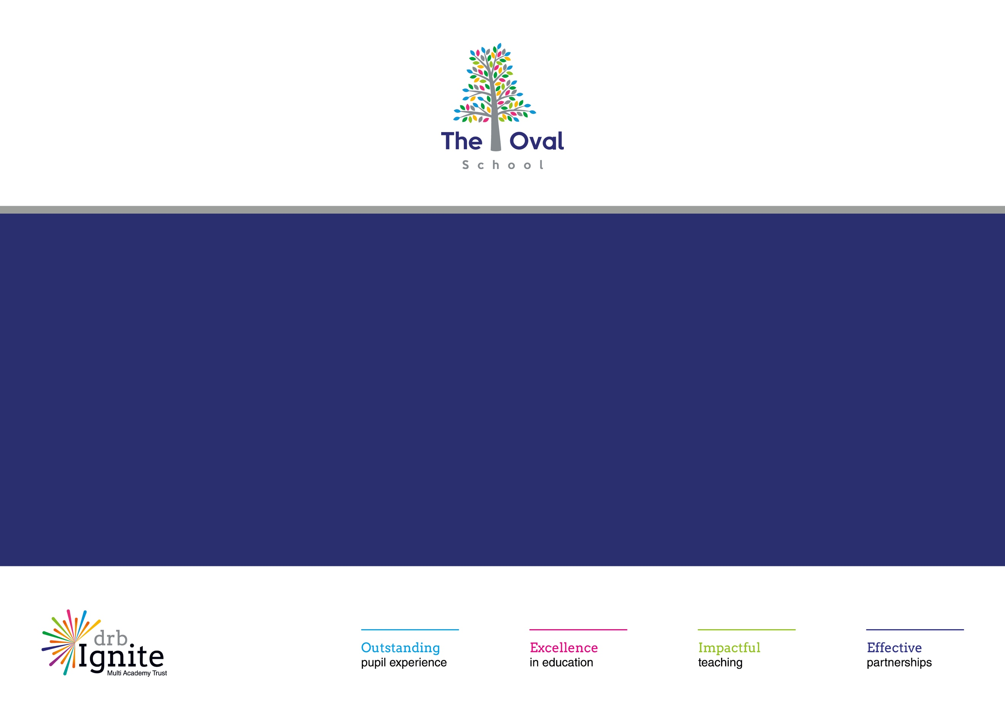

2024-2027 Accessibility Plan

The Oval School

In addition to the aims of improvement outlined in the Trust’s Accessibility Plan, The Oval will aim to:

Trust Priority One: Increasing the extent to which pupils with disabilities can participate equally across all aspects of the curriculum
Objective | Specific Actions | Responsibility | Desired Impact | Timescale | Evidence | Review
Training for teachers on adaptive teaching strategies within the curriculum. | - Undertake an audit of staff training requirements.  - Carry out learning walks and review quality of adaptive teaching strategies.  - Liaise with external agencies to identify CPD opportunities to support with adaptive teaching strategies.  - Deliver CPD on adaptive teaching strategies, linking to the Code of Practice. | SENDCo. | All children to be able to access all aspects of the curriculum, regardless of need.  Teaching team to be fully equipped to mee the needs of the pupils in their class, with regards to accessing the curriculum. | Ongoing through CPD and induction processes to new staff. | CPD notes.  External agency training records.  SENDCo CPD training records. | 2024/2025:  Trust-wide CPD (Early Complex Communicators, Makaton and Adult-Child Interaction Training)  Subject leaders and SENDCos across the Trust have developed materials for adaptive teaching for different subjects.  2025-26  In response to writing framework, SENDCos and English subject leaders have worked to create planning overviews exemplifying adaptations.  Development of semi formal and pre-formal curriculum pathways for more complex learners.  Training has been delivered by external professionals. This has included:  - WMSALT delivered:  - Brick by Brick therapy  - SEND OT delivered:  - Sensory circuit training  - CAT delivered workstation approach to adaptive delivery
Strive to ensure curriculum is fully accessible to pupils with any type of difficulty or disability. | - Provide training to develop staff skills in meeting different difficulties and/ or disabilities.  - Implement appropriate scaffolds and resources to support the curriculum.  - Embed the drb Ignite collaborative curriculum that identifies key knowledge and content as well as adaptations for pupils with SEND.  - Utilise the Ordinarily Available Guidance from Birmingham LA to inform appropriate provision.  - Collaborate with external agencies, where appropriate. | Teachers, TAs, SENDCo, Subject Leaders. | Curriculum is fully accessible for all pupils. | Ongoing through CPD and induction processes to new staff. | Planning  Book looks  Learning walks  SIT Reviews  Subject Leader monitoring | 2024/2025:  Learning walks and school development days monitor the curriculum accessibility.  Collaboration with WMSALT to support the use of alternative communication mechanisms.  Subject leaders and SENDCos across the Trust have developed materials for adaptive teaching for different subjects.  2025/2026  Continued collaboration with external professionals.  Training has been delivered on workstation approaches to curriculum delivery.
To provide specialist equipment to promote participation in learning by all pupils. | - Review need for specialist equipment with parents/ carers and relevant medical professionals.  - Liaise with specialist services (PDSS, HIS, VIS) to ensure appropriate equipment is available.  - Liaise with IT to support appropriate technology use. | SENDCo, IT Team | Children are able to participate fully in daily school life as independently as possible. | Ongoing through collaboration with specialist services and parents/ carers. | Care plans  Risk assessments  EHCP annual reviews  Termly Individual Target Plan reviews  SSPPs  External agency reports  Provision monitoring by the SENDCo | 2024/2025:  Ongoing collaboration with external professionals (OT, SSOS, HI, VI) to ensure specialist equipment is in place, as required)  2025-2026:  Ongoing collaboration with external professionals (OT, SSOS, HI, VI) to ensure specialist equipment is in place, as required)
All extra-curricular and out of school activities are planned to ensure, where reasonable, the participation of the whole range of pupils. | - Liaise with extra-curricular activity providers and/ or out-of-school organisations to ensure accessibility for all.  - Individual risk assessment to be created, where necessary, to ensure the needs of individual pupils can be met when outside of school.  - Activities identified should account for the needs of the children in the class.  - Ensure reasonable adjustments are implemented to allow participation. | Teachers, SENDCo, EVC, Subject Leaders. | Outdoor activities are inclusive of the needs of the children in the school.  Increase in access to all activities for all pupils. | Ongoing | Risk assessments  Evolve records  Extra-curricular activity monitoring | 2024/2025: Individual risk assessments utilised where appropriate.  School attended Trust-wide Sunshine Festival, promoting sporting and engagement in sporting activities for pupils with SEND.  2025-2026:  School attended Trust-wide Sunshine Festival, promoting sporting and engagement in sporting activities for pupils with SEND.  Increased opportunities for SEND pupils to attend swimming, residential and end of year celebrations  HUB pupils held sports day, parents in attendance
Trust Priority Two: Improve the physical environment, both internal and external so that pupils with disabilities can take advantage of the full range of educational and associated opportunities and experiences.
Classrooms are organised to promote the participation and independence of all pupils. | - Environment learning walks.  - Collaboration with external agencies and/or SENDCo to ensure appropriate resources are in place to meet the needs of the children and promote independence. | SENDCo, SLT, H&S Lead, Subject Leaders. | Learning environments are inclusive and prioritise learning for all children.  Resources are in place for all pupils so they can fully access the curriculum content. | Ongoing | Hub Environmental Audit.  Whole School and SEND Learning Walks.  SIT reviews.  Pupil voice.  Estate audits. | 2024/2025:  CAT strategic work.  WMSLT training to support communication friendly environments.  2025-2026  Strategic work and learning walks carried out with:  WMSALT  CAT  PSS and HS colleagues  Audit of classroom resources for adaptive learning – exemplar "box" of resources determined (to be re-issued to all classrooms in Sept 26)
Review of classroom furniture for appropriateness of size and accessibility | - Environmental audits to be carried out.  - Health and safety checklists to be completed. | SLT & H&S Lead. | Learning environments are inclusive and prioritise learning for all children. | Ongoing | Audit reports  Risk assessments | 2024-2025:  Current review identified that classroom furniture is fit for purpose. This will continue to be monitored.  2025-2026  Collaboration with PD Team to identify the correct furniture (desks and chairs) for key pupils
Ensure a Total Communication Friendly approach is adopted in all classroom settings and learning areas around school. | - Use of objects of reference/ widgit symbols/ photographs to be embedded in classroom practice.  - Use of visual timetables/ now and next board.  - Vocabulary to be prominent within the learning environment.  - Makaton signing to be used to support verbal communication.  - WellComm to be embedded within EYFS.  - Liaise with SALT to establish communication friendly environments. | SLT, SENDCo, Teachers | Learning environments are inclusive and prioritise learning for all children.  Appropriate resources are used to support verbal communication in all areas of school. | Ongoing | CPD records  Learning walks  External agency reports | 2024-2025:  Widget online subscription continued.  WMSALT providing additional support for children with more complex communications needs.  2025-2026  Makaton sign of the week shared with ALL staff.  ALD boards re-established within all classrooms  Continued collaboration with WMSALT.
Ensure review of Accessibility Audit as completed by the Estates Team. | - Review actions identified on Accessibility Audit.  - Collaborate with Estates team to identify priorities and ensure completion of actions. | Estates Team, Site Manager, Headteacher | Environment is fully accessible and maintained. | Ongoing, as managed by estates team | Learning walks  Estate team audits | 2024-2025:  Collaboration with Trust Estates Team  2025-2026:  Continued collaboration with Trust Estate’s Team
Trust Priority Three: Improve provision of information available to pupils with disabilities and parents/ carers in ways that are fully accessible to them and meet their particular needs.
To ensure that parents who are unable to attend school, because of a disability, can access events such as parents’ evenings. | - Alternative methods of communication to be agreed between school and parents/ carers.  - Collaboration with IT Team to identify assistive technology options. | SLT, H&S Lead, SENDCo, IT Team. | Parents are informed of children’s progress.  Parents can attend events by being offered appropriate support.  Parents can access all relevant information. | Ongoing | Parent voice  Records of attendance to meetings/ events  Communication logs (e.g. Dojo, Arbor). | 2024/25:  Alternative methods of communication offered (phone calls/ home visits where appropriate).  2025-2026  Alternative methods of communication offered (phone calls/ home visits where appropriate).  DoJo used across whole school  Coffee mornings and drop-in sessions arranged at various times throughout the day to support parental accessibility and availability  Regular photos / images shared with families to have visual representation of progress made
Ensure website is updated regularly and includes the relevant information. | - Review website to ensure accuracy of information. | SENDCo,  SLT,  Trust Head of Communications | Appropriate information is shared with parents. | Bi-annually | Review records  Updated information shared | 2024-2025:  Scheduled termly website checks have been completed.  2025-2026  Scheduled termly website checks have been completed.
Make available school brochures, school newsletters and other information for parents in alternative formats when specifically requested. | - Review current format options.  - Liaison with Trust IT team about other formatting options available for access.  - Consider the use of voice recording for statutory documents e.g. SEND information report. | SENDCo, SLT, Office & IT team. | Parents will be able to access relevant information in a format that is appropriate for their need. | Ongoing | Parent voice | 2024-2025:  Dojo enables translation of messages. Some widgets on different languages.  Continued collaboration with EAL group to support accessibility for parents.  2025-2026  Alternative methods of communication offered (phone calls/ home visits where appropriate).  Accessibility tool (Recite Me) has been linked to school website to further support accessibility.
Trust Priority Four: To work more effectively in partnership with parents to support and remove barriers to learning for pupils with disabilities.
Ensure parent contributions are incorporated into planned provision for pupils with SEND. | - Parents to be invited to any review meetings.  - Opportunities for parent workshops that focus on SEND support.  - Parent voice to be captured as part of ITP/ EHCP review meetings.  - Parents to be signposted to Local Offer/ SEND Support networks in Local Authority. | Teachers, SENDCo, Pastoral Lead | Parents are involved in provision planning meetings for their child. They understand what support is in place for their child and the impact it has on pupil progress.  Parents understand the pathways in place to identified SEND and support requests for EHCPs.  Parents are signposted to appropriate support services. | Termly | Parent voice  EHCP annual reviews  ITP reviews | 2024-2025:  Parents’ evening appointments offered.  Annual review paperwork sent out in in line with statutory requirements.  2025-2026  Parents’ evening appointments are offered regularly to facilitate ongoing communication between home and school. End-of-year reports provide opportunities for parents to share feedback and contribute their views on their child’s progress and provision. Annual review documentation is distributed in line with statutory requirements and includes opportunities for parental input.

